**IMAT3451 Project Contract– Development Projects**

**Student Name-Mohit Gautam**

**P-number-P15194912**

**Programme-Computer science**

**Email address-** **p15194912@my365.dmu.ac.uk**

**Project Title – Restaurant Table Reservation Android App.(Table4Me)**

**Project Proposer**

*Mr Mohit Gautam, DMU Computer science Student. P15194912*

**Supervisor**

*Dr Richard Bates, Lecturer, School of Computing,* [*Richard.Bates@dmu.ac.uk*](mailto:Richard.Bates@dmu.ac.uk)

**Introduction**

The project I am going to develop will be an android restaurant reservation booking app. In this contract I will talk about all the features that I will include on my app and I will also talk about what the aims/deliverables of my app will be. I will also talk about the risk that I could be facing throughout the project and ensure how I could prevent these problems if they occur.

**Project Background**

My app idea comes from my interest towards developing new things and I always was a very interested person in programming. The interest also came from my family run business restaurant, where sometimes the restaurant had difficulties to manage tables and allocate the bookings in certain times for the customers. Because of finding it hard to manage bookings on a busy night due to people just ringing up and saying “Could I book a table please?” and the staffs their just tend to say “yes” to all the bookings which caused many double booking and other problems.

So I think developing this app would not just help my family run restaurant, in fact it could help all the other restaurants that are out there who are finding it hard to manage the tables for their customers.

The reason I am captivated about android is on the grounds that a large portion of the hands on innovation working frameworks are android based, and I figure it will be an awesome open door for me in future also on the off chance that I figure out how to create android application.

**Aims**:

The aim of the project is that it will develop a restaurant table booking app for android devices. The app will be beneficial for both of the users (restaurant owner and the app user) this is because the app will allow users to choose the table they prefer so they can sit at their choice of the table, and on the other hand the restaurant owner won’t have to manage the tables or worry about having a double bookings as the app will do it itself automatically and only show the available tables. For this procedure to work, I will also have to develop an another app which will be used from restaurant, and through that application they can manage/update basic information by themselves such as changing the tables layout or updating pictures etc.

To achieve the aims and get app to successfully work I will need to know java code which I had experienced with during previous years in my university. However to expand my knowledge more I will have to look on to a lot of resources that are out their which would aid me with to complete the project.

**Objectives**:

There are several objectives that needs be completed for this project to be successfully developed. The list of objectives are provided below:

1) To finalise my project and sign-off a project contract, ethical review, BCS check-list and Ethical check-list for my project by week 4.

2) To conduct a literature review the current restaurant booking systems techniques, and to examine and summarise the current application and checking how were they developed and what software were used, investigate the ways to connect the application to the users and the restaurant owners. Every research and source of information will be referenced using a Harvard style referencing.

3) To produce a list of hardware and software requirements for the development of my project.

4) To produce a first submission report by end of week 7 that includes the contract, literature review, and requirements specification.

5) To design my project software using class diagrams, entity relationship diagrams, storyboards and interface designs and other appropriate tools.

6) To find a way of which will link between the customer apps and the restaurant control app, connecting the many customer apps to the single restaurant app.

7) To test my software and identify problems, document those problems, and attempt to solve those problems.

8) To produce a final report and critical evaluation of my work, with appendices detailing code and design highlights. In this report I will talk about the main purpose of the project and the functions it performs. The report will contain its introduction, body and final conclusion.

**Deliverables:**

**First Report**

Week 7

***The Deliverable will contain:***

* + - * **Project contract**

Project contract will contain all the information about how I am going to develop the project, what will I include in the project and how will I complete it.

* + - * **Ethics form**

Ethical form will contain whether if there will be any ethical issues while developing my application.

* + - * **Project Plan (e.g., Gantt Chart)**

Project plan will contain my actual plan for the project itself. I will complete this plan by creating a Gantt chart.

* + - * **Global Check-list**

To check whether if my project would have global impact, I will have to ensure whether if my project will be specifically targeted for only one restaurant or many? Will it have any impact on different religion, culture etc.?

* + - * **Literature Review**which will examine and review my app. In this review I will talk about the similar application that are out there and I will compare how my app could be different from the existing applications.
      * **Requirements Specification** *detailing the features that my app will have, and how it will function.*

**Final Report**

Week 29

***My Final deliverable report will contain the following subjects.***

* + - * Will include Case Diagrams/Descriptions/ER model/State transition diagrams of my app.
      * Story boards/Interface Designs and life-cycle of the project
      * Design Documentation
      * Test Plan and test results, verification and validation of the work, using screenshots and commenting on the codes.
      * Prototype of the application.
      * Final report, including critical evaluation.
      * Software, as in my case the software will be android studio.

**Viva examination**

**W**eeks 30-32

* + - * Oral examination, PowerPoint and demo of my app, which will take place during end of term. This examination will be formal and I will have to demonstrate my application in front of my supervisor and 2nd marker who will be there to assess my project.

**Resources and Constraints**

For the application that I will be developing, I will require an access to an android developer studio installed on my laptop. I would also need at least two android device.

I would also need to know information about the restaurant on how the owner wants the app to be. I would need access to the all the inside view of the restaurant and pictures of each tables to ensure that restaurant could choose the table that they like.

**Sources of Information**

To complete this application, I will be using a lot of sources of information. First I will have to talk to the restaurant owners and gather some basic information about the restaurant such as e.g. opening times and closing times etc.

Furthermore, to find out about different views and perspective of people towards the application that I will be developing, I will conduct a survey where it would be an anonymous , and I will use this survey as a source of useful information to talk about whether other restaurant will think if the app would be effective or not for their business.

To gain my knowledge for developing android I will be looking at tutorials videos on YouTube on how to develop the application.

**Risk Analysis**

During the process to develop the app, there might me some risk which needs to be analysed before starting my project. The risk that I could be facing throughout my project can be such things as:

* Loss of work
* Not attending the meetings
* Not following up the plan (Gantt chart)
* Personal issues/illness

However, to prevent all of these from happening I will have to take an action towards those risk and make sure they don’t happen. To do this I will make sure I will have an alternative backup plan to get the work back. To prevent any loss, I will use GitHub to store and organise my project files.

I will also try my best to attend all the meetings assigned by my supervisor. If somehow I am unable to turn up to the meeting, I will rearrange another suitable time for a meeting with my supervisor.

Another issue as I have mentioned above on the list is one of the main issue that could occur several times throughout developing my app, which is not following up with the plan. This issue could prevent my project from completing it, within the deadline period time. So for me to prevent from this issue, I will monitor my progress and take notes and ensure that I hit my planned targets on time, I will also have to make sure that I am confident on what I’m doing, asking for help with supervisor if I’m faced with my any sort of problem with my report. And I will also ensure that I keep good time management during development of my project.

**Schedule of Activities**

Finally, to track on where I am with the project and to set a plan on day to day basic I will need to have an effective plan to ensure that I complete all my project works on the set deadlines.

To set my plan, I have created a Gantt chart using a Gantt project software. the Gantt chart will contain all my scheduled planned work with set date and end date for each task.

*df*

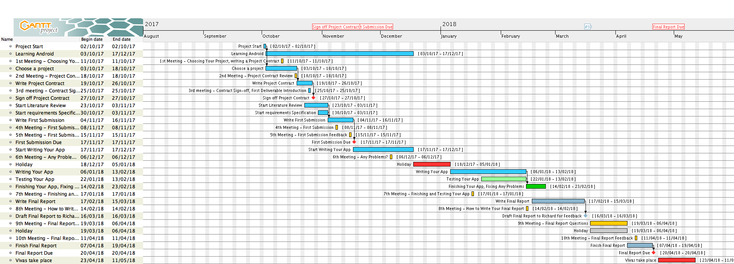

**Student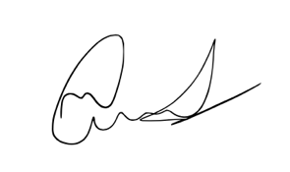 Date-27/10/17**

**Proposer Date27/10/17**



**Supervisor Date 27/10/17**